DAY 4

QUESTION 1:

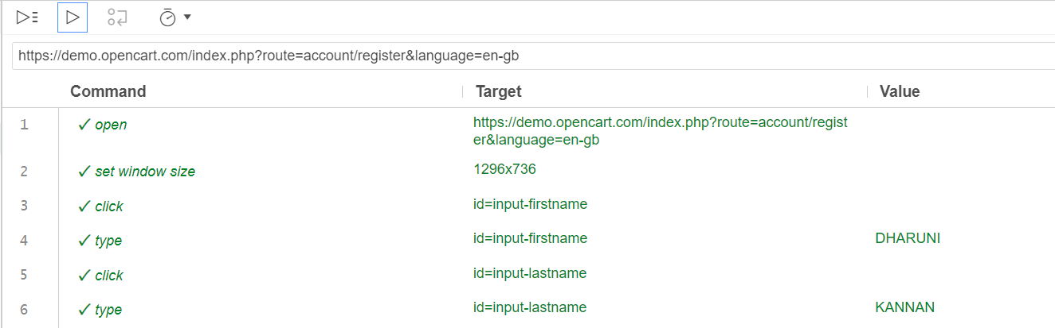

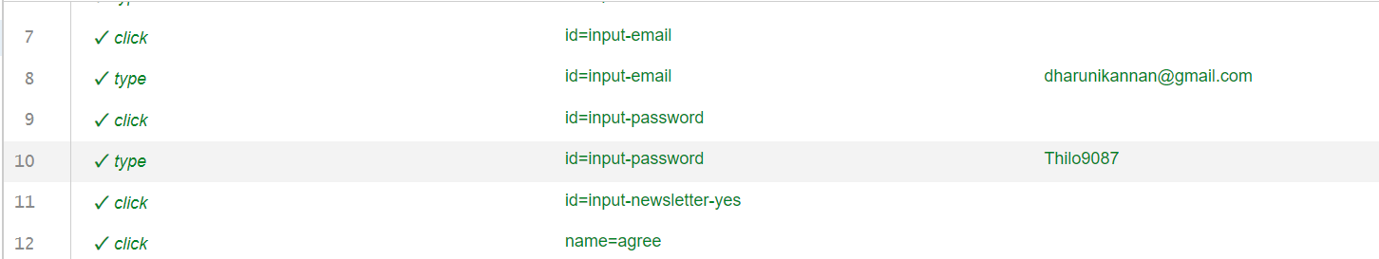

// Generated by Selenium IDE

import org.junit.Test;

import org.junit.Before;

import org.junit.After;

import static org.junit.Assert.*;

import static org.hamcrest.CoreMatchers.is;

import static org.hamcrest.core.IsNot.not;

import org.openqa.selenium.By;

import org.openqa.selenium.WebDriver;

import org.openqa.selenium.firefox.FirefoxDriver;

import org.openqa.selenium.chrome.ChromeDriver;

import org.openqa.selenium.remote.RemoteWebDriver;

import org.openqa.selenium.remote.DesiredCapabilities;

import org.openqa.selenium.Dimension;

import org.openqa.selenium.WebElement;

import org.openqa.selenium.interactions.Actions;

import org.openqa.selenium.support.ui.ExpectedConditions;

import org.openqa.selenium.support.ui.WebDriverWait;

import org.openqa.selenium.JavascriptExecutor;

import org.openqa.selenium.Alert;

import org.openqa.selenium.Keys;

import java.util.*;

import java.net.MalformedURLException;

import java.net.URL;

public class D1Test {

  private WebDriver driver;

  private Map<String, Object> vars;

  JavascriptExecutor js;

  @Before

  public void setUp() {

    driver = new ChromeDriver();

    js = (JavascriptExecutor) driver;

    vars = new HashMap<String, Object>();

  }

  @After

  public void tearDown() {

    driver.quit();

  }

  @Test

  public void d1() {

    driver.get("https://demo.opencart.com/index.php?route=account/register&language=en-gb");

    driver.manage().window().setSize(new Dimension(1296, 736));

    driver.findElement(By.id("input-firstname")).click();

    driver.findElement(By.id("input-firstname")).sendKeys("DHARUNI");

    driver.findElement(By.id("input-lastname")).click();

    driver.findElement(By.id("input-lastname")).sendKeys("KANNAN");

    driver.findElement(By.id("input-email")).click();

    driver.findElement(By.id("input-email")).sendKeys("dharunikannan@gmail.com");

    driver.findElement(By.id("input-password")).click();

    driver.findElement(By.id("input-password")).sendKeys("Thilo9087");

    driver.findElement(By.id("input-newsletter-yes")).click();

    driver.findElement(By.name("agree")).click();

    driver.findElement(By.cssSelector(".btn-primary")).click();

  }

}

OUTPUT:

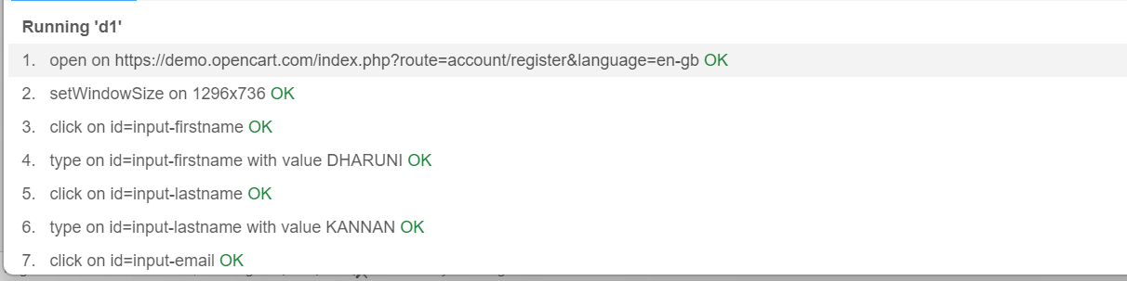

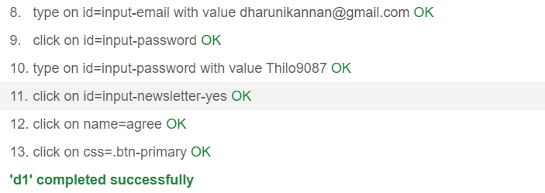

QUESTION 2:

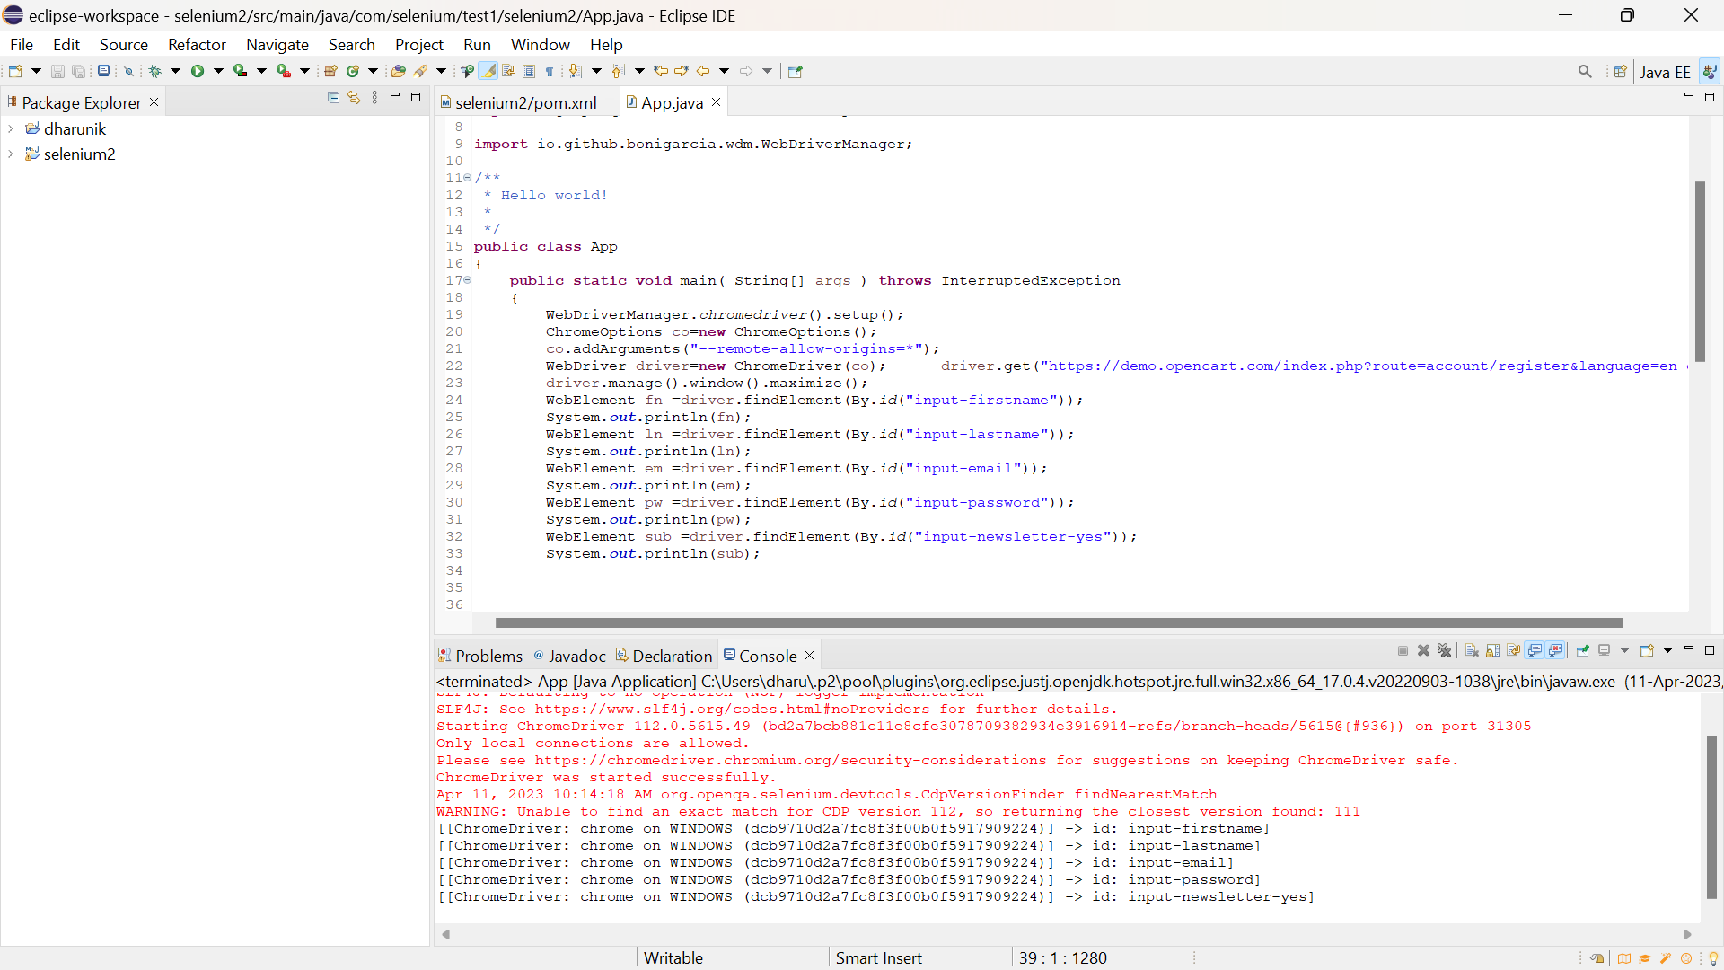

**package** com.selenium.test1.selenium2;

**import** org.openqa.selenium.By;

**import** org.openqa.selenium.WebDriver;

**import** org.openqa.selenium.WebElement;

**import** org.openqa.selenium.chrome.ChromeDriver;

**import** org.openqa.selenium.chrome.ChromeOptions;

**import** io.github.bonigarcia.wdm.WebDriverManager;

/**

* Hello world!

*

*/

**public** **class** App

{

**public** **static** **void** main( String[] args ) **throws** InterruptedException

{

WebDriverManager.*chromedriver*().setup();

ChromeOptions co=**new** ChromeOptions();

co.addArguments("--remote-allow-origins=*");

WebDriver driver=**new** ChromeDriver(co); driver.get("https://demo.opencart.com/index.php?route=account/register&language=en-gb");

driver.manage().window().maximize();

WebElement fn =driver.findElement(By.*id*("input-firstname"));

System.***out***.println(fn);

WebElement ln =driver.findElement(By.*id*("input-lastname"));

System.***out***.println(ln);

WebElement em =driver.findElement(By.*id*("input-email"));

System.***out***.println(em);

WebElement pw =driver.findElement(By.*id*("input-password"));

System.***out***.println(pw);

WebElement sub =driver.findElement(By.*id*("input-newsletter-yes"));

System.***out***.println(sub);

}

}

QUESTION 3:

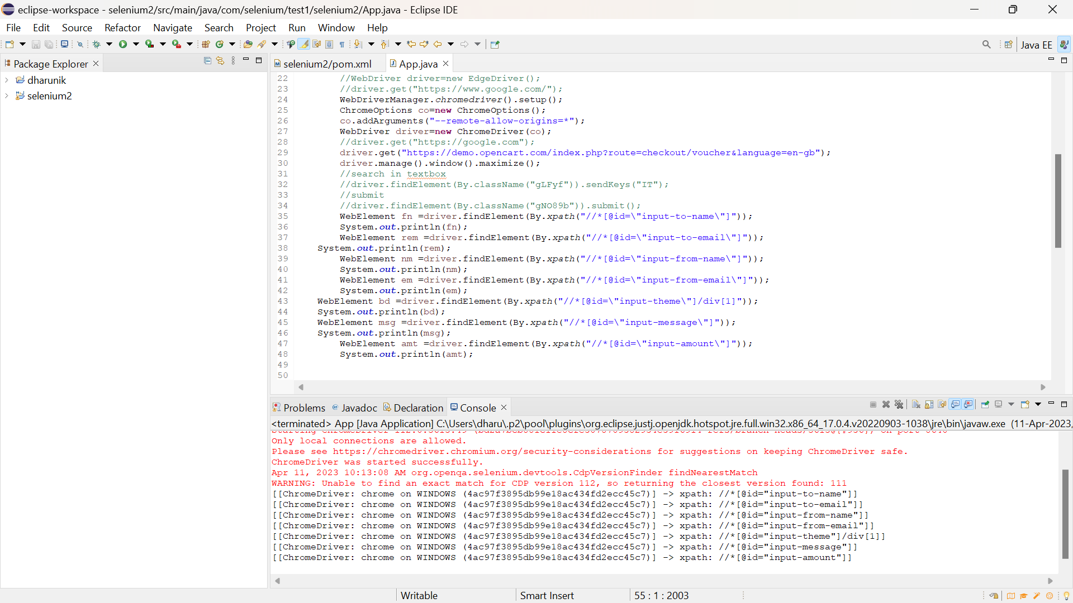

**package** com.selenium.test1.selenium2;

**import** org.openqa.selenium.By;

**import** org.openqa.selenium.WebDriver;

**import** org.openqa.selenium.WebElement;

**import** org.openqa.selenium.chrome.ChromeDriver;

**import** org.openqa.selenium.chrome.ChromeOptions;

**import** io.github.bonigarcia.wdm.WebDriverManager;

/**

* Hello world!

*

*/

**public** **class** App

{

**public** **static** **void** main( String[] args ) **throws** InterruptedException

{

//System.out.println( "Hello World!" );

//edge

//WebDriverManager.edgedriver().setup();

//WebDriver driver=new EdgeDriver();

//driver.get("https://www.google.com/");

WebDriverManager.*chromedriver*().setup();

ChromeOptions co=**new** ChromeOptions();

co.addArguments("--remote-allow-origins=*");

WebDriver driver=**new** ChromeDriver(co);

//driver.get("https://google.com");

driver.get("https://demo.opencart.com/index.php?route=checkout/voucher&language=en-gb");

driver.manage().window().maximize();

//search in textbox

//driver.findElement(By.className("gLFyf")).sendKeys("IT");

//submit

//driver.findElement(By.className("gNO89b")).submit();

WebElement fn =driver.findElement(By.*xpath*("//*[@id=\"input-to-name\"]"));

System.***out***.println(fn);

WebElement rem =driver.findElement(By.*xpath*("//*[@id=\"input-to-email\"]"));

System.***out***.println(rem);

WebElement nm =driver.findElement(By.*xpath*("//*[@id=\"input-from-name\"]"));

System.***out***.println(nm);

WebElement em =driver.findElement(By.*xpath*("//*[@id=\"input-from-email\"]"));

System.***out***.println(em);

WebElement bd =driver.findElement(By.*xpath*("//*[@id=\"input-theme\"]/div[1]"));

System.***out***.println(bd);

WebElement msg =driver.findElement(By.*xpath*("//*[@id=\"input-message\"]"));

System.***out***.println(msg);

WebElement amt =driver.findElement(By.*xpath*("//*[@id=\"input-amount\"]"));

System.***out***.println(amt);

}

}

QUESTION 4:

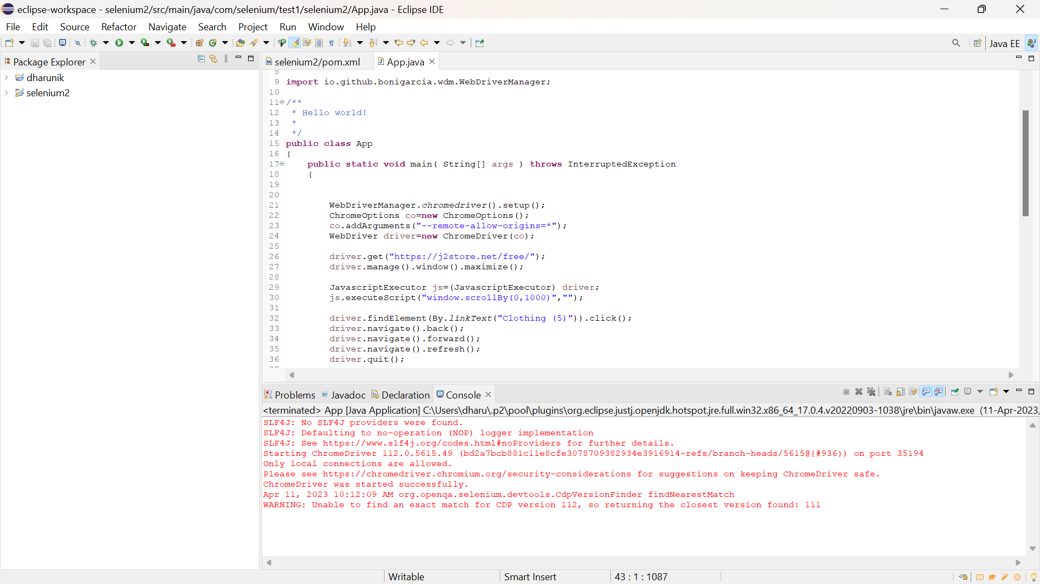

**package** com.selenium.test1.selenium2;

**import** org.openqa.selenium.By;

**import** org.openqa.selenium.JavascriptExecutor;

**import** org.openqa.selenium.WebDriver;

**import** org.openqa.selenium.chrome.ChromeDriver;

**import** org.openqa.selenium.chrome.ChromeOptions;

**import** io.github.bonigarcia.wdm.WebDriverManager;

/**

* Hello world!

*

*/

**public** **class** App

{

**public** **static** **void** main( String[] args ) **throws** InterruptedException

{

WebDriverManager.*chromedriver*().setup();

ChromeOptions co=**new** ChromeOptions();

co.addArguments("--remote-allow-origins=*");

WebDriver driver=**new** ChromeDriver(co);

driver.get("https://j2store.net/free/");

driver.manage().window().maximize();

JavascriptExecutor js=(JavascriptExecutor) driver;

js.executeScript("window.scrollBy(0,1000)","");

driver.findElement(By.*linkText*("Clothing (5)")).click();

driver.navigate().back();

driver.navigate().forward();

driver.navigate().refresh();

driver.quit();

}

}

QUESTION 5.1:

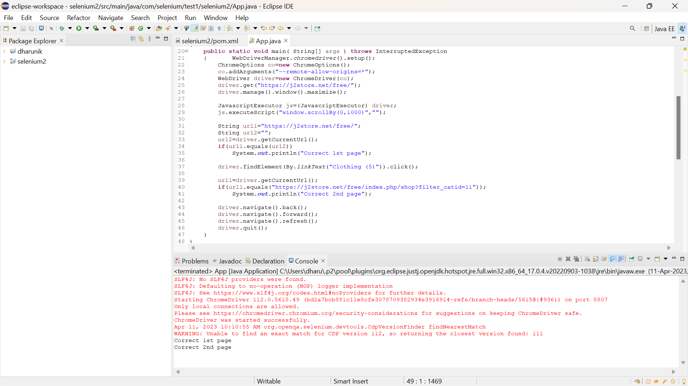

package com.selenium.test1.selenium2;

import java.util.List;

import org.openqa.selenium.By;

import org.openqa.selenium.JavascriptExecutor;

import org.openqa.selenium.WebDriver;

import org.openqa.selenium.WebElement;

import org.openqa.selenium.chrome.ChromeDriver;

import org.openqa.selenium.chrome.ChromeOptions;

import io.github.bonigarcia.wdm.WebDriverManager;

/**

* Hello world!

*

*/

public class App

{

public static void main( String[] args ) throws InterruptedException

{ WebDriverManager.chromedriver().setup();

ChromeOptions co=new ChromeOptions();

co.addArguments("--remote-allow-origins=*");

WebDriver driver=new ChromeDriver(co);

driver.get("https://j2store.net/free/");

driver.manage().window().maximize();

JavascriptExecutor js=(JavascriptExecutor) driver;

js.executeScript("window.scrollBy(0,1000)","");

String url1="https://j2store.net/free/";

String url2="";

url2=driver.getCurrentUrl();

if(url1.equals(url2))

System.out.println("Correct 1st page");

driver.findElement(By.linkText("Clothing (5)")).click();

url1=driver.getCurrentUrl();

if(url1.equals("https://j2store.net/free/index.php/shop?filter_catid=11"));

System.out.println("Correct 2nd page");

driver.navigate().back();

driver.navigate().forward();

driver.navigate().refresh();

driver.quit();

}

}

QUESTION 5.2:

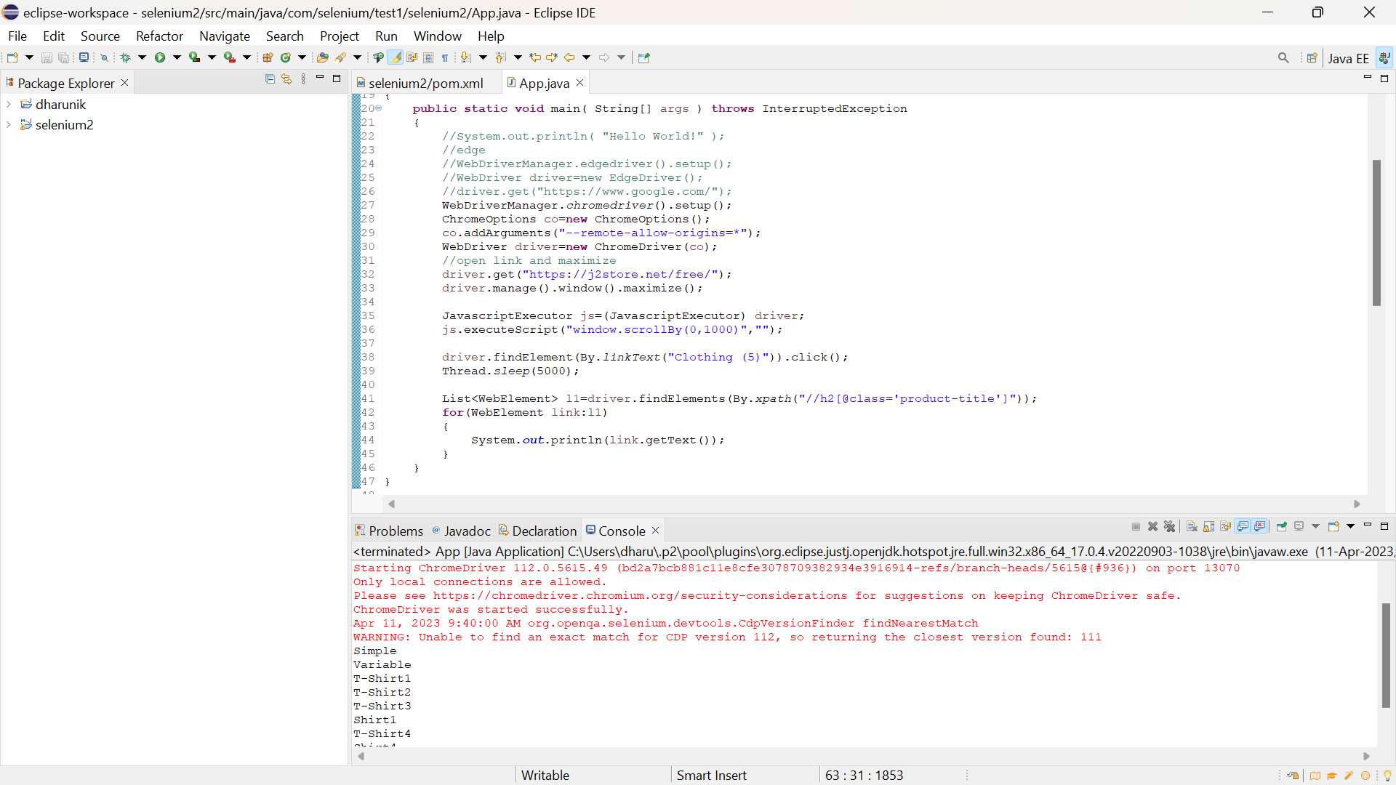

package com.selenium.test1.selenium2;

import java.util.List;

import org.openqa.selenium.By;

import org.openqa.selenium.JavascriptExecutor;

import org.openqa.selenium.WebDriver;

import org.openqa.selenium.WebElement;

import org.openqa.selenium.chrome.ChromeDriver;

import org.openqa.selenium.chrome.ChromeOptions;

import io.github.bonigarcia.wdm.WebDriverManager;

/**

* Hello world!

*

*/

public class App

{

public static void main( String[] args ) throws InterruptedException

{

//System.out.println( "Hello World!" );

//edge

//WebDriverManager.edgedriver().setup();

//WebDriver driver=new EdgeDriver();

//driver.get("https://www.google.com/");

WebDriverManager.chromedriver().setup();

ChromeOptions co=new ChromeOptions();

co.addArguments("--remote-allow-origins=*");

WebDriver driver=new ChromeDriver(co);

//open link and maximize

driver.get("https://j2store.net/free/");

driver.manage().window().maximize();

JavascriptExecutor js=(JavascriptExecutor) driver;

js.executeScript("window.scrollBy(0,1000)","");

driver.findElement(By.linkText("Clothing (5)")).click();

Thread.sleep(5000);

List<WebElement> l1=driver.findElements(By.xpath("//h2[@class='product-title']"));

for(WebElement link:l1)

{

System.out.println(link.getText());

}

}

}